**1.0 Introduction**

Here, we have developed a game “Wandering in the Woods”. This game is a dynamic and innovative educational software that has been created with the aim of making students of different grades learn about computation, and improve computational thinking, mathematical concepts, and computer science. This will be an exciting as well as educational adventure for the students. Meanwhile, students themselves will embark on a journey of discovery, taking their first steps into the world of computing and data analysis through engaging gameplay. This project's primary goal is to create an interactive and fun learning experience that transcends traditional educational boundaries. Students, both young and older, will have the opportunity to explore, learn, and grow while immersed in a game that combines entertainment and knowledge.

This captivating game concept is brought to life within a rectangular grid representing a dense forest. Students will find themselves in a maze where they can't see or hear each other until they share the same grid cell, adding an element of discovery and adventure to the learning process.

People are “lost in the woods” where the woods are represented by a rectangular grid. The woods are dense, and the people can’t see or hear each other until they are in the same cell of the grid. The project is divided into three distinct stages, each tailored to different grade levels, ensuring a gradual and seamless learning curve. Beginning with K-2 students, they'll embark on a journey of exploration as they navigate a simple square grid with two characters. As they progress to grades 3-5, students will gain more control and challenge, being able to customize the grid shape, and player placement, and interpret various statistics. For students in grades 6-8, the challenges become even more complex, allowing them to experiment with different protocols for wandering and delve into the analysis of big data sets. This project introduces concepts of big data, data interpretation, and data-driven decision-making, ensuring that older students receive a comprehensive introduction to the world of computation. This paper contains detailed information about the SRS model and software design of the game.

**1.1 Objective**

The primary purpose of developing the game is to provide an engaging and educational platform for students of different grades K-8 and improve their fundamental concepts in computer science, data analysis, and problem-solving skills. This paper serves as an initial representation of the game’s design. This paper is a combination of Software Requirements Specifications (SRS) and User's Guide offer a comprehensive understanding of the software's goals and functionality, making it a valuable tool for educational purposes.

**1.2 Wandering in the Wood Designer**

The game design for "Wandering in the Woods" is tailored to deliver an engaging and educational experience for students across different grade levels (K-2, 3-5, and 6-8). At its core, the game concept involves characters navigating through a grid-based forest with the primary objective of making them meet within the grid.

For K-2 students, the gameplay is intentionally simple, with characters moving randomly on a rectangular grid, offering an introduction to concepts like randomness and coordinates. Visual and auditory feedback reinforces interaction and data generation, ensuring accessibility and enjoyment for younger learners.

In grades 3-5, students gain more control, customizing the grid shape, and number of characters, and interpreting statistics, like longest and shortest runs. Collaboration is encouraged, and the game introduces challenges to foster problem-solving skills.

For grades 6-8, students can experiment with advanced grid parameters, explore data analysis, and conduct experiments to optimize meeting strategies. The game design aligns with the project's educational goals, providing a progressive and comprehensive learning experience for students.

**2.0 Process Model**

A process model is a visual representation of a series of steps or tasks of a system. We have used the evolutionary process model as shown in Figure 1. This model incorporates agile principles offering an iterative and flexible framework that aligns perfectly with the project’s goals. The model allows for swift prototyping of game components. This is essential in a project aimed at creating an engaging learning experience that can be adjusted and refined iteratively. During the development process of the game, we collaborated and communicated with the team members effectively.

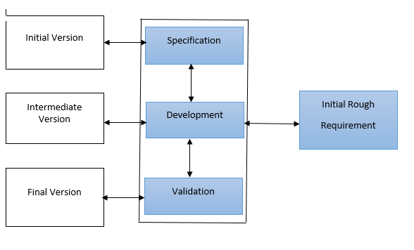

*Figure 1. The Game Designer Process Model*

**3.0 Use Cases**

For the “Wandering in the Woods Game '' project, aimed at teaching computational thinking and computer science concepts to K-8. In this project, we describe some user cases outlining the core system requirements for the delivery of a working prototype. These use cases are categorized based on the different stages of the game, designed to accommodate several grade levels.

**3.1 Use case 1: Basic Simulation (Grades K-2)**

**Primary Actor:** K-2 Student

**Preconditions:** The game is launched.

**Description:** As a student, I want to be able to start the basic simulation. I

observe two characters in opposite corners of a square grid

and watch them wander randomly in the woods. I can reset

the game.

**Acceptance Criteria:** Inthe K-2 students, I can able to start the basic simulation

and observe characters in opposite corners of a square

Grid randomly wandering in the woods.

**3.1 Use case 2: Configure intermediate Simulations(Grades 3-5)**

**Primary Actor:** Grade 3-5 Student

**Preconditions:** The game is in the intermediate stage

**Description:** As a student, I can configure the grid size (square or

rectangular), select 2, 3 or 4 characters, and place

characters at their desired positions in the grid.

**Acceptance Criteria:** During Grades 3-5 students, I can be able to configure the

grid size (square or rectangular ), choose between 2, 3, or 4 characters, and place them at their preferred position within the grid during the intermediate stage of the game.

**3.3 Use case 3: Run intermediate Simulation (Grades 3-5)**

**Primary Actor:** Grades 3-5 students

**Preconditions:** The game is in the intermediate stage with the grid and

characters configured.

**Description:** As a student, I want to be able to start the intermediate

simulation, observe character movements, and track

Statistics such as longest run without meeting, shortest run,

and average run.

**Acceptance Criteria:** During the intermediate stage, I can able to start the

simulation, observe character movements, and accurately

track statistics, including the longest run without meeting,

shortest run, and average run for the configured characters

and grid.

**3.4 Use case 4: Configure Advanced Simulation (Grades 6-8)**

**Primary Actor:** Grades 6-8 student

**Preconditions:** The game is in the advanced stage

**Description:** As a student, I can configure the grid size and character

placement, and conduct experiments to explore how the

average run varies with grid characteristics and wandering

protocols.

**Acceptance Criteria:** As a student in the advanced stage, I should be

able to initiate the advanced simulation, closely monitor character movements influenced by their settings, collect relevant data, and perform a comprehensive analysis to understand how various factors affect the average run of characters on the grid.

**3.5 Use case 5: Run Advanced Simulation (Grades 6-8)**

**Primary Actor:** Grades 6-8 student

**Preconditions:** The game is in the advanced stage with grid and character

settings.

**Description:** As a student, I want to be able to start the advanced

simulation, observe character movements based on their

settings, and collect data to analyze how different factors

impact the average run.

**Acceptance Criteria:** As a Grades 6-8 student in the advanced stage, I should

be able to initiate the advanced simulation, closely monitor character movements influenced by their settings, collect relevant data, and perform a comprehensive analysis to understand how various factors affect the average run of characters on the grid

**3.5 Use case 6: Modify Simulation ( All Grades )**

**Primary Actor:** All students

**Preconditions:** The game is running in any stage

**Description:** As a student, I can interact with the simulations by stopping,

starting, resetting, and reconfiguring parameters such as grid size characters, or wandering protocols.

**Acceptance Criteria:** I can seamlessly interact with the simulation at any stage,

including the ability to start, stop, reset, and modify parameters such as grid size, characters, or wandering protocols, ensuring a dynamic and engaging user experience.

**4.0 UML Model**

**4.1 Use Case Diagram**

The eleven use cases are included in the use case diagram as seen in Figure 2. Here the actors are students of different grades, such as k-2, 3-5, and 6-8. The complex level of the game gradually increases with the grades. Students can choose the levels of the game according to their grades. For K-2 Level the grid is always square. Players begin in diagonally opposite corners of the square grid. For grades 3-5 levels, the students can choose between square and rectangular grid shapes. They can move randomly in the game. For 6-8 levels, students will have advanced control over the grid parameters, including size, shape, and density.

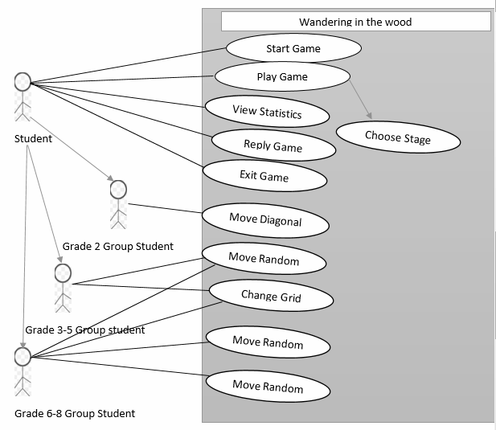

*Figure 2. The Game Designer Process Model*

**5.0 Persona**

There is a persona of the game in Figure 3. For a project, it is important to have a persona in order to evaluate it.

| Sarah | She is 10 years old. She is in 4th grade.  An enthusiastic and curious student who has a keen interest in computer science and mathematics.  Enjoys both classroom studies and interactive learning through games. | Comfortable using computers, tablets, and educational software.  Natural curiosity about how things work and often asks questions to gain a deeper understanding.  Wants to stimulate her problem-solving skills and encourage her to make data-driven decisions. |
| --- | --- | --- |

*Figure 3. The Persona of a Student*

**6.0 Conclusion**

The Wandering in the Woods game project is a dynamic as well as innovative educational initiative that will help to improve the different skills of students of different grades. This paper contains different aspects of developing the game, such as use case diagrams, use cases, etc. which will help the users.